FINAL PROJECT

CM 3070

DRAFT REPORT

Table of Contents

Abstract 3
Introduction 4
Literature Review 5
Automated Essay Scoring (AES) Systems 5
Transformers 5
Optical Character Recognition (OCR) 6
Automated Speech Recognition (ASR), Speech-To-Text (STT) 7
Multimodal Systems 8
Challenges and consideration for component selection 11
Evaluation Plan 15
Evaluation Metrics 15
Procedure 16
Design 17
Project Management 21
Feature Prototype 23
Appendix A 27
Appendix B 30
Reference List 37

Abstract

Automated Essay Scoring is a rapidly developing research areas in NLP with respect to education. According to [1] this is due to the rapid progress in Artificial Intelligence which has created new possibilities. Some of the benefits of AES are enhanced fairness, consistency and efficiency in the scoring process [2]. This research has shown Optical Character Recognition (OCR) technology has the potential to provide accessibility to an AES system by allowing essays to be submitted in handwritten format as images. In limited experimentation with only two handwritten samples, PaddelOCR achieved average CER and WER scores of 0.771 and 0.962 respectively. This research investigates whether orchestrating OCR and ASR models along with a Transformer can produce an AES system this interpretable, accessible and reliable.

Introduction

Proposed System
BrainPower- A hybrid, multi-modal, Automated Essay Scoring (AES) system which orchestrates an OCR, STT and Transformer model, providing accessibility for students and interpretability, readability and automation in support of human scorers.
Template of Choice
Template 4.1 Project Idea 1: Orchestrating AI models to achieve a goal
Why the interest in the topic?
Reading and providing corrective feedback on a single 250-word essay can take 10-15 minutes on average and a typical English A class has 35 students. This manual approach does not scale well if a teacher is assigned to more than one class. As an educator, the author recognizes the stressful, time-consuming ordeal that educators endure when marking answers to open-ended questions, especially essay. Currently accessibility for students who can speak but are incapable of writing or typing due to disability is provided by means of a scribe. Although well intentioned, this arrangement demands extra human resources, is time consuming and can be intimidating to some students. It would be more beneficial to the student if they could submit an answer to a prompt independently by verbally expressing their ideas recording, transcribing and then having them evaluated. There should also be a mechanism in place to allow students who are unable to be present at school to be able to under supervision write essays and share photographs or scan copies of these essays.

Literature Review

Automated Essay Scoring (AES) Systems
Key terms: traits, features, handmade features, engineered features, holistic score, QWK, neural networks, transformers, prompts
What is AES?
According to [3] Automated essay scoring refers to the process of grading student essays without human interference. An AES system takes as input an essay written for a given prompt (the topic) and then assigns a numeric score to the essay reflecting its quality, based on traits such as content, grammar and organization. [3] proposed a system that uses a neural approach which holistically scores an essay. A holistic score is a single numeric value assigned to an essay after evaluation, reflecting its quality, without providing evidence of how the score was obtained [4].
Neural approaches engineer features like sentence length and number of paragraphs and encode these in dense numerical feature vectors. This enables them to iteratively adjust weights to learn a model that can then generalise to score new essay. These models have performed better than their predecessors according to [5], in some cases achieving QWK scores of 0.72 [7] and above.
[1] compared the performance of three neural approaches LSTM, Bi-LSTM and BERT a transformer model and concluded that the transformer model offered superior performance. [4] reviewed several pretrained models in AES and discovered that BERT, outperformed all of them achieving a QWK of 0.83. QWK (Quadratic weighted Kappa) evaluates the degree of agreement among human and AI scorers, it is a metric between 0 and 1, representing no agreement beyond chance and perfect agreement, respectively [5].

Transformers
Transformer models work by using an attention mechanism that relates each token in the text to every other token thus enabling them to capture long-range contextual dependencies. As effective as stand-alone neural approaches are, they are usually criticized for their lack of readability and interpretability by humans. A dense vector can contain several numerical values relating to a feature or combination of features. These numbers have not positional significance to humans as compared to handcrafted features as they are assigned based on weight adjustments influenced by gradient descent. Handcrafted features, however, are values that are encoded into feature vectors for example the first dimension of a vector representing word count and the second, sentence length and so on. These are then fed to a neural network for processing. This way features have positional value and the output from processing is interpretable.
[6] suggests not relying solely on transformer models and like [7], proposed a technique of combining transformers with more traditional approaches like those that employ handcrafted features. [5] argued that human evaluation remains important since expert markers can identify subtle linguistic and cognitive qualities that automated systems may overlook. [7] indicated that when models work in combination the results are more promising. [8] used a hybrid model – LSTM and Word Embedding and achieved a QWK of 0.94. [6], [7] and [8] all give compelling reasons for a hybrid design for an AES system but give not explicit indication of the format that the essay must be in for evaluation. This presents a gap as none of the cited research papers mention input modality.

Optical Character Recognition (OCR)
[9] defines OCR as a computational technology that extracts text in an editable format from PDF files, scanned or hand-written documents, images etc. [10] describes traditional OCR systems as comprising two modules: a text detection module and a text recognition module. Text detection localizes all text blocks at word-level or text-line level while text recognition aims to understand the text image content and transcribe the visual signals into natural language tokens[10].
Mostafa et al [11] summarized work done using OCR to digitize Bangla scripts - a diverse and complicated language in written form. They concluded that CNN architectures are the most accurate tried and tested method for that task. [11] stated that the transformer models showed promise but also acknowledged that there is no empirical evidence of Bangla scripts being extracted with them.
[10] achieved state-of-the-art results on printed, handwritten and scene text image datasets without any complex pre/post-processing steps with Tr-OCR, an end-to-end Transformer-based model. The model achieved world-level precision, recall and F1 scores of 96.59, 96.57 and 96.58 respectively on the SROIE (Scanned Receipts OCR and Image formation Extraction) dataset and achieved a state-of-the art CER (Character Error Rate) of 2.89 on the IAM Handwriting Dataset. A study carried out by [12], where YOLOv10, an object detector, was integrated with Tr-OCR and PaddleOCR for reliable text detection, found that Tr-OCR provided the best overall solution for reliable, high-accuracy container ISO code recognition with a recognition accuracy of 92% outperforming a PaddleOCR a hybrid CNN-Transformer model.
[13] PaddleOCR is an open scource OCR model launched by Baidu Paddle. The architecture always maintains the three-stage Pipeline design of “text-detection + direction classification + text recognition”. [13] tested the model on a dataset containing 200 national grids stand slogans and power supply line maps collected on the spot at a power generation environment. The images were captured at different angles under varying lighting conditions. The model achieved high detection accuracy of over 95% for standardized slogans and power supply circuit diagrams. It also achieved 93.3% and 86.6% average recognition for standardized slogans and power supply circuit diagrams respectively [13]. These studies focused on OCR, but ASR presents an optional modality for presenting an essay for evaluation.

Automated Speech Recognition (ASR), Speech-To-Text (STT)
[14] for STT the system accepts an audio input signal from either a person or a machine and detects and converts individual words and phrases into text. [15] Advances in deep learning technology has profoundly transformed automatic speech recognition (ASR) over the past decade. Historically, ASR systems were constructed from a complex pipeline of independently trained components for example, a pronunciation model (lexicon) and a language model (LM). Like early AES system, features had to be hand engineered, which was tedious and did not scale well.
[16] described how three major research groups- Microsoft Research (MSR), Google and IBM Research, achieved significant improvements in a variety of state-of-the-art ASR systems with Deep Neural Networks. According to [15] the modern era of ASR is defined by firstly, a shift towards end-to-end (E2E) models – systems that learn a direct mapping from acoustic features to text using a single, jointly optimized neural network which simplifies training and improves performance. Secondly, a shift in the data paradigm. Early deep learning system used supervised learning to train on large dataset of labelled data. Modern systems have moved towards unlabelled data. Self-supervised systems have demonstrated the ability to learn from raw audio data while weakly supervised systems have demonstrated the ability to generalise to data it was never trained on [15].
[17] One model that exemplifies this shift is OpenAI’s Whisper, a transformer. [18] For translation tasks, the Transformer can be trained significantly faster than architectures based on recurrent or convolutional layers. The Wisper model trained on an enormous dataset of with 680,000 hours of labelled audio. Whisper transcribed 950 out of 1000 words correctly in research carried out by [19] achieving 95% accuracy. The model’s integration into classroom technology effectively supports students with diverse linguistic, cultural, and ability-based needs. Achieving high accuracy and frequency responsiveness. Whisper is a valuable tool for educators seeking to foster a more accessible learning environment [19].

Multimodal Systems

This section discusses some multimodal systems that share some similarity with BrainPower but however, fail to provide in entirety for all input modalities, catering to students who have writing disabilities.
An extensive search of Google Scholar, IEEE Explore, ACM and similar services and querying current AI applications like ChatGPT and Gemini with the search terms “multimodal AES”, “accessible multimodal AES” and “hybrid multimodal AES” reveals that such systems are exceptionally rare. The results returned were of systems that orchestrated at most two AI models of disparate modality. This indicates a gap in current AES technology revealing that most AES systems ignore input equity.
There are however commercially available multimodal systems such as IntelliMetric®, whose architectures are not freely available for analysis. My research project intends to fill the gap by implementing an accessible, interpretable, hybrid, multimodal AES system by orchestrating three pre-trained models – an OCR, ASR and a transformer model that accepts as input, written, typed and spoken essays and transparently scores them.
[20] proposed a multimodal AES system called CAFES that uses a MLLM to process graphics e.g. a scenery along with text. The system orchestrates GPT-4o, as the MLLM. The dataset used for their experiment is ESSAYJUDGE dataset which consists of 1,054 multimodal essays written at the university level. This dataset is limited in that it does not cover complex visual inputs such as film frames. This system although multimodal, is still not designed to cater to students with disabilities, as it, like other AES systems ignores input equity.
[21] developed a multimodal system ExaGrade the integrates optical character recognition (OCR) with the generative pre-trained transformer (GPT). The platform integrates two pre-trained models - HandwritingOCR to extract text from handwritten exam papers and like [20] employs GPT-4 to evaluate and score student responses. The platform offers features such as exam creation where for MCQs and TFs the teacher supplies the answers. Student exam completion using handwritten or online modalities.
The platform is described as accessible; however, accessibility only encompasses availability online at GitHub since the platform is released as an open-source project [21]. ExaGrade is not accessible to students with writing disabilities. Notably absent from the system is a means to input an essay in audible form.
[22] proposed VisualAES, a bi-modal system that utilizes both textual and visual features for handwritten essay scoring. It orchestrates three pretrained transformer-based models to take both textual features and visual features extracted by Faster R-CNN and then uses a stacking ensemble model to robustly map their output to a final score. This system’s architecture is more congruent with what is being proposed in this research – and OCR model to convert text from scanned essays to digital text for processing, and a transformer model for essay scoring. VisualAES was evaluated on the Automated Student Assessment Prize (ASAP) dataset and their own handwritten Chinese Student’s handwritten essay dataset (ChnStd). Their results showed that their system outperformed all state-of-the-art methods on both datasets. VisualAES like CAFES does not provide accessibility for students suffering writing disability.
[19] developed an inclusive learning classroom using OpenAI Whisper model. The model was selected to promote diversity and inclusivity in education through real-time transcription and translation for students with diverse linguistic and cultural abilities and backgrounds. The results were encouraging as the model achieved high accuracy especially in an environment where ambient noise did not alter the audio signal input. This system however is limited in input modality as it only focuses on audio transcription with no allocation made for submission of handwritten work.
[23] developed a system for investigating the possibility of automatically grading handwritten essays by leveraging OCR together with a fine-tuned and trained Large Language Model (LLM) Mistral 7b. According to the BERT Score analysis, the precision, recall and F1 scores were observed to be consistent over all the essays. The F1 score of 85.78% demonstrates the model’s overall stability in replicating human-grading decisions with a high degree of consistency. The system used a Moodle plugin that integrated Mistral 7b into the Platform. There is no mention of inclusivity in the system developed by [23] showing once again that most modern AES systems focus on the quality of essay scoring and do not priority input equity, emphasizing the need for an integrated system.

Challenges and consideration for component selection

The datasets
According to [6], the most elaborate AES systems currently have trouble accurately evaluating the coherence and persuasiveness of an essay, or an argument’s clarity, and that is due to two main reasons: (1) such aspects are very hard to model, and (2) the lack of datasets that provide human-graded dimension-specific data, especially compared to those that provide holistic scoring. [4] indicates that the problem originates from AES research rely heavily on the ASAP dataset as the primary benchmark, highlighting the limited options available. Additionally, most publicly available datasets are tailored toward English-language assessment e.g., TOEFL11, CELA, or the Cambridge English assessment datasets.
[20] further emphasizes this limitation, describing the ASAP and its extended version, ASAP++, as both containing few topics. [20] ASAP++ adds trait-level annotations but merges key content traits into a single “CONTENT” label, decreasing granularity and interpretability. The TOEFL11 dataset, similarly, uses only coarse-grained proficiency labels (low / medium / high). Thus, models trained on the TOEFL11 dataset will inherently produce results that are difficult to interpret due to the granularity of the training data [20].
[4] also points out that the dataset availability and diversity issue is not limited to the field of research, but extends to commercial products, which primarily focus on English-language datasets. The quality, quantity, and availability of the data are fundamental to the model’s performance. It is fitting to consider available models, discuss the impact the limited datasets have on them and propose the best option to provide reliable, interpretable trait scoring.
The models
[4] presents some of the issues with Transformers pretrained models as having a closed-box nature, high computational requirements, longer training times and the need for large datasets. Additionally, issues presented by [4] are data quality, biases in training data, generalization, and overfitting which still pose significant obstacles that need to be addressed. [
21] cited three studies that showed the limitations of ChatGPT a transformer model, as an AES tool. The results indicated that ChatGPT often scores lower than human scorers and its evaluation is inconsistent due to variations in its scoring mechanism, training data, model updates, and ingrained randomness. [21] Additionally, the consistency of ChatGPT’s scores over multiple evaluations was low, indicating variability and raising concerns about its reliability.
[24] explored the potential of using GPT-based models as an alternative solution to the data scarcity issue, comparing their performance to that of fine-tuning BERT models, which remains the state-of-the-art, in quantitative text analysis. They concluded that BERT models remain the overall go-to method for classification although GPT models can serve as alternatives on smaller tasks. GPT models are also easier to tweak, however, they are more expensive. Due to the findings of [21] and [24] GPT will not be included in this system.
[25] DeBERTa (Decoding-enhanced BERT with Disentangled Attention) is an improvement of previous state-of-the-art pre-trained transformer models such as BERT and RoBERTa, its predecessors. [25] BERT and RoBERTa represents each word in the input layer by a single vector which is the sum of its word (content) embedding and position embedding. Each word in DeBERTa, however, represents a word with two vectors that encode its content and position, respectively, and the attention weights among words are computed using disentangled matrices based on their contents and relative positions [25].
[25] DeBERTa, after training on 78GB of data, outperformed RoBERTa, which was trained on 160GB of data and also surpassed human scoring on the SuperGLUE benchmarks for the first time since 2021. This benchmark includes a wide range of tasks such as question answering, natural language inference, and word sense disambiguation [25].
DeBERTa has been selected to form the core component in the essay processing pipeline for BrainPower, serving as the final step before the end user receives a breakdown of how the traits are scored. This decision is based on the empirical research that showed it outperforming human scorers and other state-of-the-art models on established benchmarks, making it more suitable for the AES task. DeBERTa is also freely available from the Hugging Face platform and offered under the MIT licence, facilitating freedom of modification and reproducibility.
Limitations of OCR
The accuracy of OCR models in recognizing text from images depends on the quality of its input image. High quality images have clear, uncluttered text, no background noise (such as smudges) and are captured in well-lit environments. Most classroom environments, however, do not provide all these conditions. Furthermore, quality of images is determined by the photographer’s ability to hold the camera steady and the quality of the camera used to capture the image. Consequently, selection of an appropriate model is critical to preventing errors from propagate through the pipeline as errors fed into the core (DeBERTa) will degrade its scoring accuracy.
Several popular models struggle to decipher handwritten text or are only capable of extracting text from one language. Others are limited to handling only single lines of text and cannot scan whole documents, making it necessary for a text extraction add-on. One such example is Tr-OCR, according to [26], which is designed for single-line text detection and failed to extract text from full-page or paragraph-level images, in one experiment achieving a low accuracy of around 50-60%, in text extraction [26].
It is for these reasons, along with the findings of [13] discussed previously, that PaddleOCR has been selected as the OCR input component for BrainPower. Since it is beyond the scope of this research to fine-tune a model, the capabilities of PaddleOCR make it an ideal candidate for inclusion in BrainPower’s AES pipeline.
Limitations of ASR (STT)
[27] noise interference, echoes, accents, dialect variation and overlapping speech have a degrading effect on the performance of speech-to-text (STT) and text-to-speech (TTS) systems, resulting in transcription errors. As with OCR systems, ASR systems are vulnerable to environmental conditions as these determine the quality of the input, which invariably determines the quality of the output. According to [27], model and dataset scarcity are the reasons why the issues mentioned earlier still pose a challenge to modern ASR systems.
This issue of dataset scarcity seems to be a common thread among modern AI models, since they rely heavily on data for training and testing, underscoring the need for greater diversity and availability. These limitations are taken into consideration however, and Whisper will serve as the ASR/STT component of BrainPower due to its accessibility and state-of-the-art performance. The results from both component and integration testing will indicate if the model needs to be fine-tuned or replaced.
Limitations of Multimodal Integrated Systems
Multimodal integrated systems inherently suffer the same issues as their constituent components – OCR, ASR, and Transformer models. Additionally, they face issues such as:
- Computational complexity: orchestrating three pretrained models requires a lot of processing power and storage space.
- Error propagation: It is likely that mistakes from either the audio transcription done by the ASR or from recognition and digitization by the OCR will flow as input to the AES system core. If errors in the input data are not detected and handled correctly, they will propagate and reduce the core component’s accuracy and reliability, resulting in inaccurate essay scores.
- Modality imbalance: Typed essays may score higher than handwritten or audio-transcribed essays due to noise introduced by OCR or the accent or dialect of the speaker for example.
- Data Bias: The pre-trained models are inherently biased towards the data they were trained on
It is therefore incumbent on the designer to mitigate error propagation by detecting errors in the output from the ASR and OCR using metrics such as WER and CER and managing them at the component level, alerting human scorers when review is necessary.

Evaluation Plan

Evaluation Metrics

Accuracy and Precision
Accuracy rate is a measure of the number of correct classifications over the entire test set, indicating the strength of the classifier [28]. [29] Precision is the fraction of correctly predicted, positive results out of the sum of all positive predictions (true positives + false positives). This number is useful in situations where the false-positives outnumber the false-negatives. A high-precision value suggests that the model makes accurate positive predictions.
Recall on the other hand [30] indicates how well the classifier labels as positive, cases that are positive, showing the ability to correctly identify cases that are positive. This measure is also described as sensitivity.[29] the F1-Score is a measure of the test’s accuracy and is calculated from the precision and recall of the test.
Word Error Rate (WER)
[31] The WER metric is used to measure the percentage of words that are incorrectly recognized or translated by the OCR Engine compared to a reference (ground truth) text.
The WER equation is as follows: WER = $\frac{S+D+I}{N_{W}}*100$, where:S = number of word substitutions (words in the recognized text that are different from the ground truth). D = number of word deletions (words missing in the recognized text but present in the ground truth text). I = number of word insertions (extra words present in the recognized text but not in the ground truth text)
Character Error Rate (CER)
[32] this metric counts any deletions, insertions or substitutions at the character level, enabling evaluation based on character-wise accuracy. CER works well in spotting symbol, typographical and abbreviation mistakes.
[31] The formula is as follows: CER = $\frac{CRC}{N_{C}}*100$, where: CRC = number of correctly recognized characters and N_{C} = total number of characters in the ground truth text

Procedure
To evaluate the performance of the system the following approach will be used:
Data input to OCR – WER and CER metrics will be calculated and used to determine whether the output should be sent to the core for further processing or a flag raised for human scorer intervention
Data input to ASR- WER and CER metrics will be calculated and used to determine whether the output should be sent to the core for further processing or a flag raised for human scorer intervention
Data input to AES – will output trait scores along with a QWK which will be used to describe proximity of the system’s scores to that of human scorers along
Datasets –this research will use the ASAP dataset for training and testing BrainPower
Testing Plan
About 25 students will be selected to form the sample. Each student will produce one handwritten essay, after which they will snap a photograph with their phone and forward for collection. The students will also be required to record a reading of the essay. Thus the sample data should comprise 25 written and 25 audio samples of the same essay. Only one prompt will be used, the purpose of this test is to determine whether the ocr and asr are suitable for inclusion in the AES system.
What prompt will be used? What model? What parameters? System specs model will be run on?
- A sample of 10 individuals will each write five (5) essays selected from the dataset. Each essay relates to a different prompt. These will then be scanned with and OCR scanner and be captured by camera and then submitted to the system via the OCR component.
  - Test tweaks:
    - Taking photos under different light conditions
    - Crumpling scripts and the scanning/photographing
    - Smudging scripts and scribbling in the margin
- Each member of the sample will read each of the five essays they wrote and record their voice then input the audio via the ASR component of the system
  - Test tweaks:
    - Various background noises will be used to obscure the input signal replication real-world classroom conditions

Design

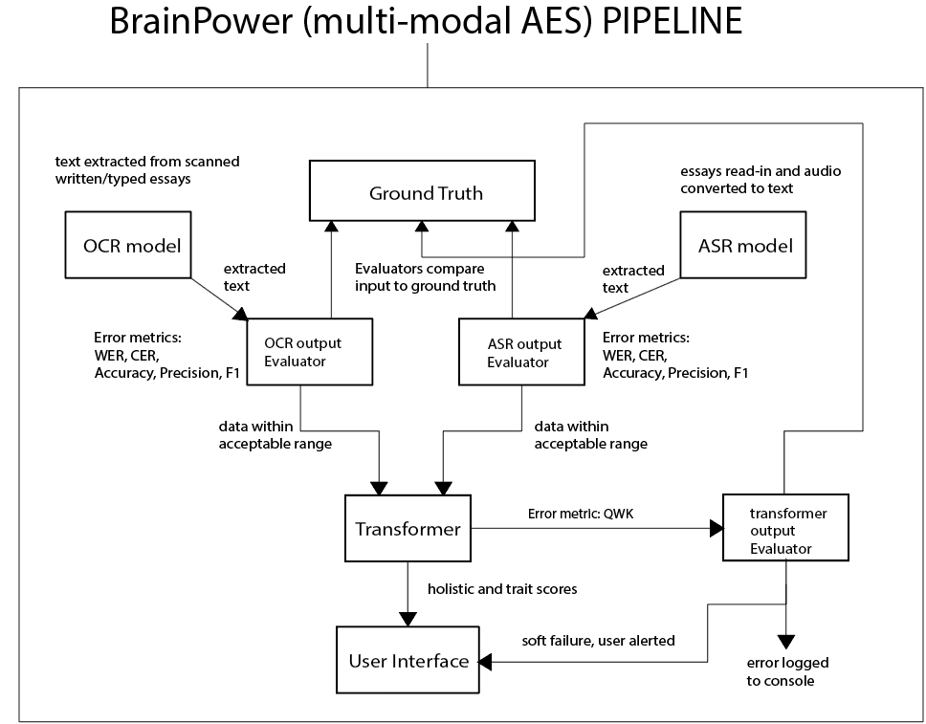
Figure 1 Architecture of BrainPower

Typical Workflow:
Scenario 1:
- Input (image of handwritten or typed essay) submitted to the OCR model
  - Model extracts text from the image and outputs digital text to its Evaluator
  - OCR Evaluator runs metrics such as WER, CER etc. referencing ground truth
    - Results within acceptable range: text forwarded to transformer for evaluation
    - Unacceptable results: system displays message to user, fails softly, logs process
Scenario 2:
- Input (read-in essay) submitted to the AST/STT model
  - Model extracts text from the audio and outputs digital text to its Evaluator
  - ASR Evaluator runs metrics such as WER, CER etc. referencing ground truth
    - Results within acceptable range: text forwarded to transformer for evaluation
    - Unacceptable results: system displays message to user, fails softly, logs process
Scenario 3:
- Input (essay in text format) submitted to the Transformer model
  - Model processes text and logs results to its Evaluator
  - Transformer Evaluation runs metrics such as QWK referencing ground truth
    - Results within acceptable range: text displayed to human scorer
    - Unacceptable results: system displays message to user, fails softly, logs process

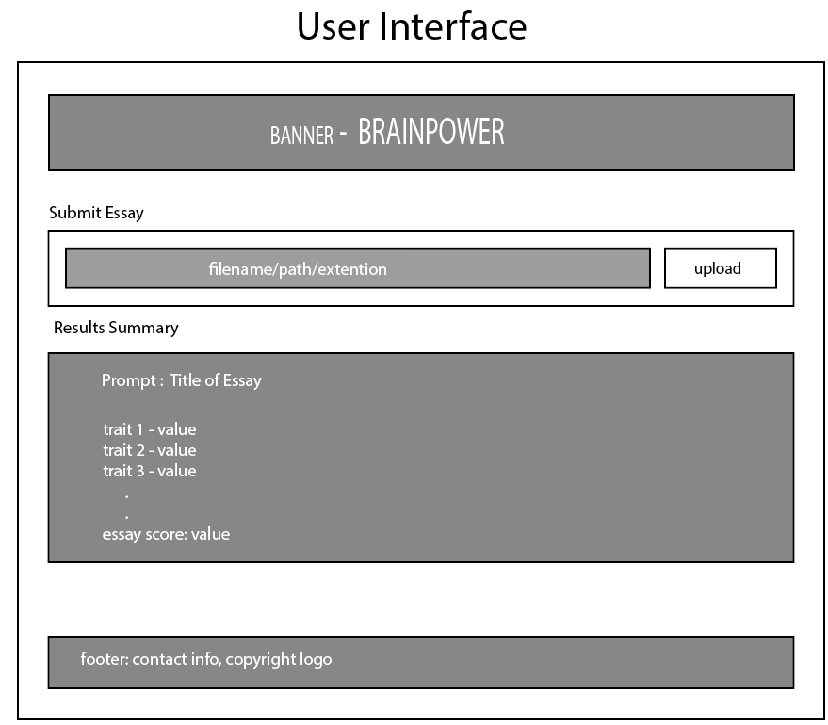
Figure 2 User interface for BrainPower system
User-interface components:
- Banner: this section displays the name of the application and may contain links or a form for user login
- Submit Essay(s): this section is designed to allow the user to upload the essay in disparate formats e.g. pdf, wav, or jpeg, for evaluation. The user will click on the upload-button, and a window will display to allot them to choose a file(s) for scoring. This section supports diversity as essays can be uploaded as both image, document and audio files.
- Results: this section will display the output after the transformer model processes and scores the input file. The textual display will comprise of traits and their respective trait scores and a final holistic score. This is to satisfy the readability and interpretability requirements of the system.
- Footer: this section will contain copyright data as well as links to sections for correspondence such as contact us form/page. This section does not contribute to the pipeline however it does contribute to the overall aesthetic of the system and follows the conventional web interface design paradigm.
Models
deberta-v3-base
PP- OCRv6
whisper-base.en
In-scope
- User Interface – Webpage, Django Web Framework
- OCR model – PaddleOCR - PP-OCRv6_medium_det
  - English Language only
- STT/ASR model – OpenAI - whisper-large-v3
  - English language only
- Transformer model – Microsoft – deberta-v3-base
  - English language output only
- Local execution
- Back end – Sqlite3
Out of scope
- Multi-lingual input/output, limited to English
- Multiple choice exams evaluation
- Long answer questions evaluation
- Reading comprehension exercise evaluation
- (scene text) Essays with visual prompts/visual content such a scene along with a prompt requiring students to write about the scene.
- Text-to-audio conversion

Project Management

Overleaf is a Gantt chart, displaying all tasks that comprise the workflow for the development of system, and the estimated time required for their completion. This chart does not indicate the presence of dependencies, however, these will be outlines in this section. Some of the key milestones and dependencies are as follows:
- Component Tests (ASR, OCR, Transformer): These millstones are critical because the ASR, OCR and Transformer models are the three main components of the AES system – failure in either the ASR or OCR component will propagate and results in an inaccurate, unreliable essay score. Successful results here move the system towards completion.
- Sample collection: The collection of samples (images and audio of essays), is a key milestone because it allows the system to be tested on a component level and as a complete unit.
- Integration Testing: completion of this task is critical as the User Interface Design process requires the system’s output to provide feedback to the end-user from the AES evaluation process. Success also indicates that the penultimate hurdle has been achieved and the system is near-ready for presentation to the end-user.
- User Interface Design: this task is critical because user testing depends on its completion. A fully functional interface is necessary for the user to interact with the system and provide timely feedback the will be used to make improvements to the system.
- User Testing: This stage is critical because success here is the sole metric for evaluating the system and determining if the end-goal has been achieved.

Gantt Chart

Figure 3 Gantt Chart for BrainPower AES project

Feature Prototype
Feature: OCR component (model: PP-OCRv6_medium_det)
Overview: this component in the AES pipeline is to accept essays input as images, extract the text from the image, then forward the text to the core transformer (DeBERTa) for essay evaluation and scoring.
Overarching Goal: To satisfy the requirements for a system that is accessible and supports diversity and inclusivity by facilitating the submission of essays in multiple formats, for evaluation, specifically, scanned or photographed handwritten essay, and essays submitted as image files.
Objective: demonstrate PaddleOCR’s ability to accurately extract handwritten text from an image file
Justification for Selection: This feature was selected over the ASR and Transformer components for three (3) main reasons
- Position in the AES pipeline: this represents the first stage in the AES processing pipeline as output from this stage is fed into the Transformer component.
- Error Propagation: Errors from this component can propagate to the Transformer resulting in inaccurate essay scores.
- Controlled experimentation: the process of handwriting an essay (copying in this case from a reference essay) allows the component to be evaluated under controlled and repeatable conditions.

Procedure:
Phase 1: Essay Preparation
Three handwritten copies of essay with ID AAAVUP14319000159574, from the from the ASAP2.0 dataset will be made. (see Appendix A for the samples)
Essay Features (Ground Truth)
Essay ID | AAAVUP14319000159574
Prompt | Exploring Venus
Word Count
Sentence Count
Paragraph Count | 2, truncated from 5, to fit on one sheet
Table 1Essay features (Ground Truth)
Phase 2: Essay Capture
The image of the document will be captured with a cell phone camera
Cell phone Specifications (sample 1)
Brand+ Model | Motorolla + moto g G5 - 2023
Camera Resolution | 48 MP
Operating System | Android 14
Flash Used (yes/no) | Yes
Distance from paper | ~11 inches
Cell phone Specifications (sample 2)
Brand+ Model | Samsung + SM-A065M
Camera Resolution | 50 MP
Operating System | Android 14
Flash Used (yes/no) | No
Distance from paper | ~9 inches
Cell phone Specifications (sample 3)
Brand+ Model
Camera Resolution
Operating System | Android 14
Flash Used (yes/no)
Distance from paper | ~
Table 2 Specification of phone used to capture image of essay
Phase 3: OCR Extraction
The image file will be uploaded to the OCR model for text extraction
Sample 1 Image Properties
Resolution | 899 * 931
Size | 1.79KB
Extension | .jpg
Colour/Black and White | Colour 24-bit
Sample 2 Image Properties
Resolution | 1110 * 1264
Size | 238.7KB
Extension | .jpg
Colour/Black and White | Colour 24-bit
Table 3 Properties of image of essay
Phase 4: Calculate Metrics
The Character Error Rate (CER) and Word Error Rate (WER) will be calculated to evaluate the model’s accuracy in extracting handwritten text from an image
Success Criteria:
- The model successfully extracted text from the image and
- The model achieves a CER and WER percentage below 2%

Results:
Results
 | Sample1 | Sample2 | Average
Character Error Rate (CER) | 0.868 | 0.674 | 0.771
Word Error Rate (WER) | 1.085 | 0.838 | 0.962
Table 4 Results from prototyping PaddleOCR
These results show that the OCR component successfully extracted handwritten text and converted it to digital text. They also show the success criteria was achieved as the figures obtained all fall below the 2% ceiling.
Limitations:
The images were taken under relatively good lighting conditions. The text was clear; there was no evidence of smudges or creases. The writers maintained good form, keeping all text on the lines and the styles were consistent. The sample size was very small and as such is not sufficient to comprehensively evaluate the performance of the OCR model as it was not representative of the real-world conditions that essays will have to be written, captures and submitted under.
Future Work:
Future work will involve testing with more diverse samples and a larger population size, to obtain more realistic conditions to better evaluate the performance of the OCR component.
Conclusion:
The results show that the paddleOCR can be considered for candidacy as a key part of the AES system, promoting accessibility, diversity and inclusivity. The initial results fell within an acceptable range demonstrating the model’s ability to accurately extract handwritten text from and image and convert it to digital text. However, the presence of errors indicates the need for mitigation which will be implemented with future improvements to the system.

Interface
The researcher though it wise to use a single upload form to make it easier for the user and have the user specify only the format of the essay. The system will then route the essay to the correct component based on the format specified in the upload.
Models
The researcher decided to implement the application using the Django framework. The database stores the essay id, the text of the original and processed essays, the feature, trait and holistic scores, the file type, the prompt, the processing status and the character and word error rate values. Storage was deemed necessary to allow the data and process to be transparent and persist for future reference.

System Deployment/Implementation Details
Scripts to download models
Scripts to upload data for processing
Installation instruction, requirements.txt installation
Appendix A

Reference Essay (Ground Truth)

Essay ID: AAAVUP14319000159574
Prompt: Exploring Venus

The author suggests that studying Venus is worthy enough even though it is very dangerous. The author mentioned that on the planet's surface, temperatures average over 800 degrees Fahrenheit, and the atmospheric pressure is 90 times greater than what we experience on our own planet . His solution to survive this weather that is dangerous to us humans is to allow them to float above the fray. A "blimp-like" vehicle hovering 30 or so miles would help avoid the unfriendly ground conditions . At thirty-plus miles above the surface, temperatures would still be toasty at around 170 degrees Fahrenheit, but the air pressure would be close to that of sea level on Earth. So not easy conditions, but survivable enough for humans. So this would help make the mission capeable of completing.
He also mentions how peering at venus from a ship orbiting or hovering safely far above the planet can provide only limited insight on ground conditions because most forms of light cannot penertrate the dense atmosphere making it hard to take photographs . They also cannot take samples of rock, gas, or anything else, from a distance. So many reaserchers are working on innovations that would allow their machines to last long enough to help gain some imformation of Venus.

Sample 1
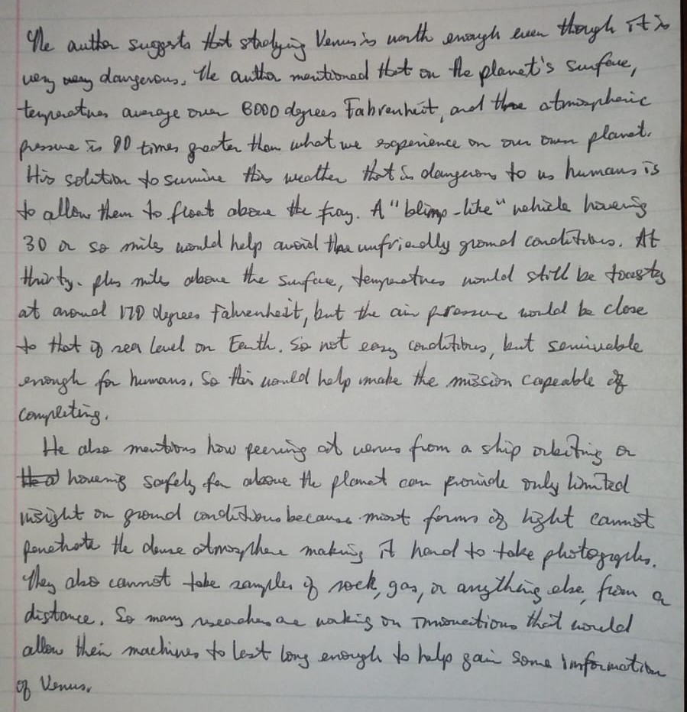

Sample 2
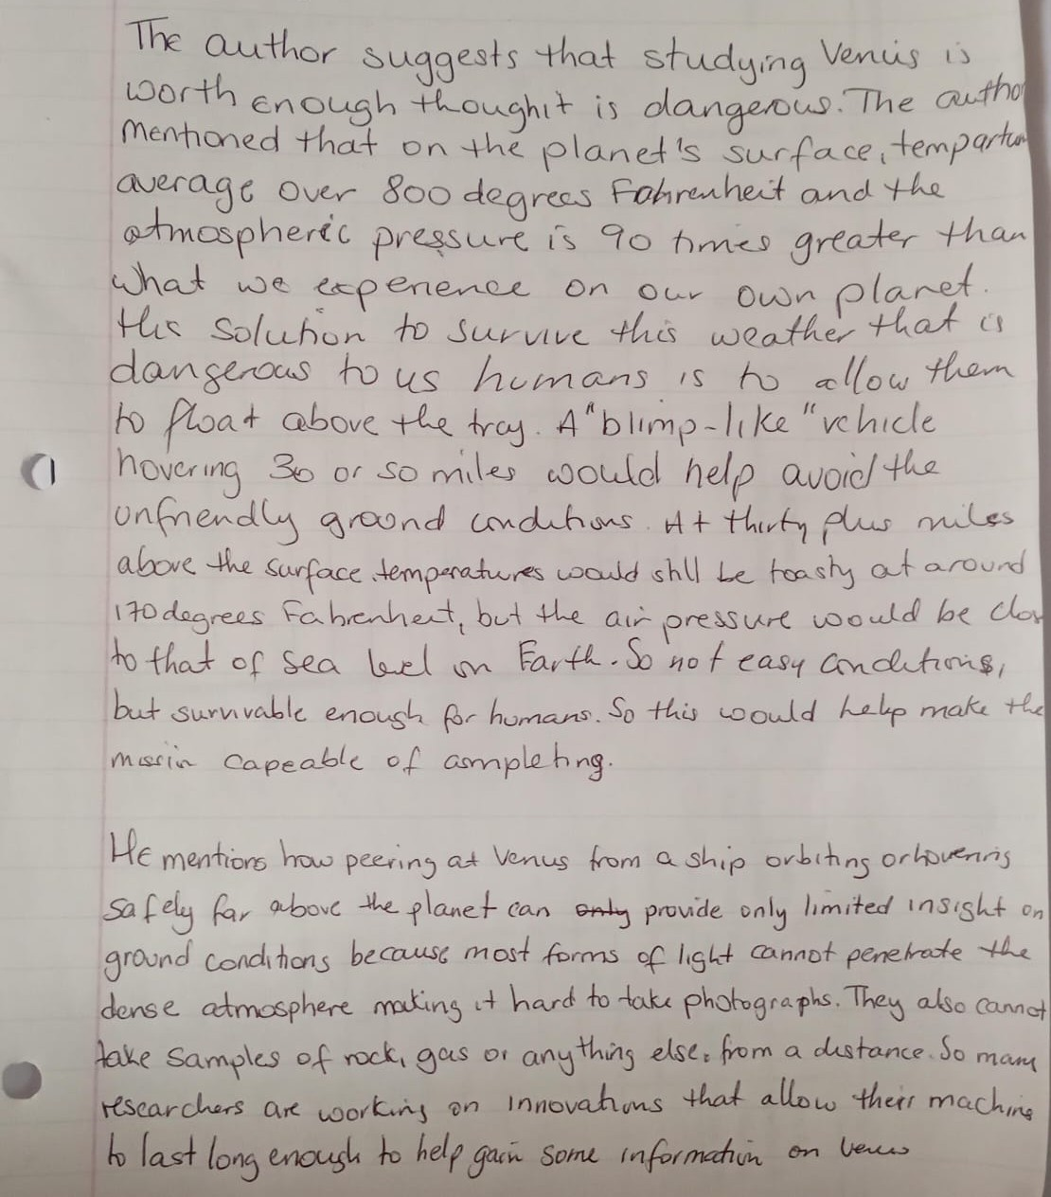

Appendix B

Code Used for Prototyping (Jupyter Notebook)

<h3 id="Prototyping-PaddleOCR-for-text-extraction">Prototyping PaddleOCR for text extraction</h3>
#Note: Almost all othe test here was copied from ChatGPT at one point
#or the other and later modified, the function names and logic is
#original to the researcher

#Ground truth
import pandas as pd
df = pd.read_csv("sample_essay.csv")

#OCR text extractor
#from PaddleOCR ReadME file
from paddleocr import PaddleOCR

ocr = PaddleOCR(
text_detection_model_name="PP-OCRv6_medium_det",
text_recognition_model_name="PP-OCRv6_medium_rec",
engine="transformers",
use_doc_orientation_classify=False,
use_doc_unwarping=False,
use_textline_orientation=False,
)

#Feature Extractor
import nltk
nltk.download('punkt_tab')

def feature_extractor(essay):
# Count sentences using tokenizer
sentences = nltk.tokenize.sent_tokenize(essay)
sentence_count = len(sentences)

# Count words
words = nltk.tokenize.word_tokenize(essay)

# Filter out punctuation so only words remain
words = [word for word in words if word.isalnum()]
word_count = len(words)

print(f"Words: {word_count}")
print(f"Sentences: {sentence_count}")

#Clean Text
import re

def clean(text):
text = text.lower()
text = re.sub(r"[^\w\s]", "", text)
text = re.sub(r"\s+", " ", text).strip()
return text

#Return cleaned text
def get_cleaned_text (extracted_text):

# Filter texts with a confidence score > 0.65
threshold = 0.65
filtered_texts = [
text for text, score in zip(result[0]['rec_texts'], result[0]['rec_scores'])
if score > threshold
]

all_text = "\n".join(filtered_texts)

return clean(all_text)

# Metrics -----------adapted from ChapGPT
from jiwer import wer, cer

def calculate_error_rates(ground_truth, ocr_output):

word_error_rate = wer(ground_truth, ocr_output)
character_error_rate = cer(ground_truth, ocr_output)
return [word_error_rate, character_error_rate]

Creating model: ('PP-OCRv6_medium_det', None, 'transformers')
Model files already exist. Using cached files. To redownload, please delete the directory manually: `C:\Users\cowse\.paddlex\official_models\PP-OCRv6_medium_det_safetensors`.
Loading weights: 0%| | 0/350 [00:00<?, ?it/s]
Creating model: ('PP-OCRv6_medium_rec', None, 'transformers')
Model files already exist. Using cached files. To redownload, please delete the directory manually: `C:\Users\cowse\.paddlex\official_models\PP-OCRv6_medium_rec_safetensors`.
Loading weights: 0%| | 0/269 [00:00<?, ?it/s]
[nltk_data] Downloading package punkt_tab to
[nltk_data] C:\Users\cowse\AppData\Roaming\nltk_data...
[nltk_data] Package punkt_tab is already up-to-date!
<h4 id="Displaying-the-Ground-Truth">Displaying the Ground Truth</h4>
ground_truth = df.iloc [0, 2]

#Clean Text
ground_truth = clean(ground_truth)

#Show cleaned essay
print(ground_truth)

#Show ground_truth features
print("\n")
feature_extractor(ground_truth)
the author suggests that studying venus is worthy enough even though it is very dangerous the author mentioned that on the planets surface temperatures average over 800 degrees fahrenheit and the atmospheric pressure is 90 times greater than what we experience on our own planet his solution to survive this weather that is dangerous to us humans is to allow them to float above the fray a blimplike vehicle hovering 30 or so miles would help avoid the unfriendly ground conditions at thirtyplus miles above the surface temperatures would still be toasty at around 170 degrees fahrenheit but the air pressure would be close to that of sea level on earth so not easy conditions but survivable enough for humans so this would help make the mission capeable of completing

Words: 130
Sentences: 1
<h4 id="Extracted-text-from-Sample-1">Extracted text from Sample 1</h4>
#Extract text
result = ocr.predict("./sample_1.jpeg")
#Clean text
sample_1_text = get_cleaned_text(result)
#Show cleaned essay
print(sample_1_text)
#Show sample_1 features
print("\n")
feature_extractor(sample_1_text)
wey y dangerou the autha mentioned het on he planets sfene his solition to sumine this weather that sn danguon to us humans is to allow them to float abone the fay a blimplihenehicle hoverss 30 on so mils wonld help auoid the unfriondly gromel condlitibes at thirty fhes mile abome the sunface tempeaatues would still be tousts at anoned 17d degrees fabrenheit but the ain prossue would be close to that if rea level on eenth so not easy condititrus but semiuable enough for humans so this wanld help make the mission capeable o comreitiis he alse mantions how feering af wenns from a ship orbeting on hat houemig safely for alasne the flamet com proninde only limted isight on grond conditiousbecanse miost forms ds hight camnmst fonethote the deuse atmozpthere makisg it handl to take photogigihs they aso cannst tobe sample of sock gas on ansthaing ebse from a distance so many useaches ae wakis on tmonactions that would

Words: 161
Sentences: 1
<h4 id="Extracted-text-from-Sample-2">Extracted text from Sample 2</h4>
#Extract text
result = ocr.predict("./sample_2.jpeg")
#Clean text
sample_2_text = get_cleaned_text(result)
#Show cleaned essay
print(sample_2_text)
#Show sample_1 features
print("\n")
feature_extractor(sample_2_text)
the author suggests that studying venis is worth enough thoughit is dangerous the author average over 8oo degrees fahrenheit and the atmospheric pressure is 90 times greater than what we expenence on our own planet thhis solution to survive this weather that is dangerous to us humans is to allow them to float above the tray ablimplike vchicle hovering 3o or so miles would help avoid the unfrendly ground cnditions itt thirty plus miles above the surface temperatures would shill be toasty at around 170degrees fabrenheit but the air pressure would be clos to that of sea lbeel on farth so no f easy anditions but surnvable enoush for homans so this would help make the missin capeable of asmpleting he mentions how peering at venus from a ship orbiting orhouennis safely far above the planet can oty provide only limited insight on ground conditions becouse most forms of light cannot penetrate the denseatmoeemainhartotakpotogratheyaa take samples of rok gas or any thing else from a distance so mam researchers are workins on innovatons that allow therr machine to last long enough to help garin some information on venw

Words: 189
Sentences: 1
<h4 id="Word-and-Character-Error-Rates">Word and Character Error Rates</h4>
#metrics for sample_1
sample_1_errors = calculate_error_rates(ground_truth, sample_1_text)
print("Sample 1 - Results")
print(f"Word Error Rate (WER): {sample_1_errors[0]:.3f}")
print(f"Character Error Rate (CER): {sample_1_errors[1]:.3f}\n")

#metrics for sample_2
sample_2_errors = calculate_error_rates(ground_truth, sample_2_text)
print("Sample 2 - Results")
print(f"Word Error Rate (WER): {sample_2_errors[0]:.3f}")
print(f"Character Error Rate (CER): {sample_2_errors[1]:.3f}")

#Average Error Rates
avg_wer = (sample_1_errors[0] + sample_2_errors[0])/2
avg_cer = (sample_1_errors[1] + sample_2_errors[1])/2
print(f"\nAverage Word Error Rate (WER): {avg_wer:.3f}")
print(f"Average Character Error Rate (CER): {avg_cer:.3f}")
Sample 1 - Results
Word Error Rate (WER): 1.085
Character Error Rate (CER): 0.868

Sample 2 - Results
Word Error Rate (WER): 0.838
Character Error Rate (CER): 0.674

Average Word Error Rate (WER): 0.962
Average Character Error Rate (CER): 0.771

Reference List

[1] I. M. G. S. Artha, A. S. Kusuma, and P. Sugiartawan, "A Comparative Study of Semantic Similarity, Rubric-Based, Generative AI, and Hybrid Scoring Methods for Automated Essay Evaluation," in Proc. 2026 International Seminar on Intelligent Business and Edge-Computing Research (ISIBER), 2026, pp. 656–661, doi: 10.1109/ISIBER68248.2026.11470541.
[2] K. S. S. Han and M. T. Myint, "A Comparative Study of LSTM, Bi-LSTM, and BERT for Automated Essay Scoring," in Proc. 2024 5th International Conference on Advanced Information Technologies (ICAIT), 2024, pp. 1–6, doi: 10.1109/ICAIT65209.2024.10754925.
[3] K. Taghipour and H. T. Ng, "A Neural Approach to Automated Essay Scoring," in Proceedings of the 2016 Conference on Empirical Methods in Natural Language Processing (EMNLP), Austin, TX, USA, Nov. 2016, pp. 1882–1891, doi: 10.18653/v1/D16-1193.
[4] A. M. Elmassry, N. Zaki, N. Alsheikh, and M. Mediani, "A Systematic Review of Pretrained Models in Automated Essay Scoring," IEEE Access, vol. 13, pp. 121902–121917, 2025, doi: 10.1109/ACCESS.2025.3584784.
[5] W. Xu, R. Mahmud, and W. L. Hoo, "A Systematic Literature Review: Are Automated Essay Scoring Systems Competent in Real-Life Education Scenarios?" IEEE Access, vol. 12, pp. 77639–77657, 2024, doi: 10.1109/ACCESS.2024.3399163.
[6] P. Lagakis and S. Demetriadis, "Automated Essay Scoring: A Review of the Field," in Proc. 2021 International Conference on Computer, Information and Telecommunication Systems (CITS), Istanbul, Turkey, Jul. 2021, pp. 1–5, doi: 10.1109/CITS52676.2021.9618476
[7] J. Yang, "Automated Essay Scoring in Education," in Proc. 2024 4th International Conference on Educational Technology (ICET), 2024, pp. 170–175, doi: 10.1109/ICET62460.2024.10868446.
[8] R. Dadi and S. K. Sanampudi, "A Robust Model for Automated Essay Scoring System," in Proc. 2024 International Conference on Computational Intelligence and Sustainable Engineering Solutions (CISES), 2024, pp. 1–6, doi: 10.1109/CISES62520.2024.10712145.
[9] P. Jain, K. Taneja, and H. Taneja, "Which OCR Toolset is Good and Why? A Comparative Study," in Proc. 2021 International Conference on Computational Performance Evaluation (ComPE), Shillong, India, 2021, pp. 640–646, doi: 10.1109/ComPE53109.2021.9752243.
[10] M. Li, T. Lv, J. Chen, L. Cui, Y. Lu, D. Florencio, C. Zhang, Z. Li, and F. Wei, "TrOCR: Transformer-Based Optical Character Recognition with Pre-trained Models," arXiv preprint arXiv:2109.10282, 2021.
[11] M. T. Mostafa, E. R. Rhythm, M. H. K. Mehedi, and A. A. Rasel, "Advancements in Optical Character Recognition for Bangla Scripts," in Proc. 2023 International Conference on Electrical, Computer and Communication Engineering (ECCE), 2023, pp. 1–6.
[12] J. Q. Cheok, K. C. Lim, and C. E. Si, "Maximizing Recognition Reliability: TrOCR Outperforms PaddleOCR in Challenging Container Automation Environments," International Journal of Research and Innovation in Social Science (IJRISS), vol. 9, no. 11, 2025, Art. no. 91100629, doi: 10.47772/IJRISS.2025.91100629.
[13] B. Wang, T. Zhao, L. Dong, Z. Yu, and Y. Qian, "Application of PaddleOCR in Power Consumption Environment Text Recognition," in Proc. 7th Int. Academic Exchange Conf. on Science and Technology Innovation (IAECST), 2025, pp. 1562–1566, doi: 10.1109/IAECST68792.2025.11415173.
[14] A. Elakkiya, K. Jaya Surya, K. Venkatesh, and S. Aakash, "Implementation of Speech to Text Conversion Using Hidden Markov Model," Proc. 2023 International Conference on Intelligent Computing and Control Systems (ICICCS), 2023, pp. 1–5.
[15] M. S. Tabrej, K. J. Deb, M. A. Hakim, and S. Goswami, "Automatic Speech Recognition in the Modern Era: Architectures, Training, and Evaluation," Proc. 2023 International Conference on Artificial Intelligence and Data Engineering (AIDE), 2023, pp. 1–6.
[16] G. Hinton, L. Deng, D. Yu, G. E. Dahl, A.-r. Mohamed, N. Jaitly, A. Senior, V. Vanhoucke, P. Nguyen, T. N. Sainath, and B. Kingsbury, "Deep Neural Networks for Acoustic Modeling in Speech Recognition," IEEE Signal Processing Magazine, vol. 29, no. 6, pp. 82–97, 2012, doi: 10.1109/MSP.2012.2205597.
[17] A. Radford, J. Kim, T. Xu, G. Brockman, C. McLeavey, and I. Sutskever, "Robust Speech Recognition via Large-Scale Weak Supervision," arXiv preprint arXiv:2212.04356, 2022.
[18] A. Vaswani, N. Shazeer, N. Parmar, J. Uszkoreit, L. Jones, A. N. Gomez, Ł. Kaiser, and I. Polosukhin, "Attention Is All You Need," in Advances in Neural Information Processing Systems (NeurIPS), 2017, pp. 5998–6008.
[19] K. Hlongwane, S. Mthethwa, and L. Manqele, "Enhancing Diversity in Inclusive Learning Classroom Using OpenAI Whisper Model," in IST-Africa 2025 Conference Proceedings, M. Cunningham and P. Cunningham, Eds., IST-Africa Institute and IIMC, 2025, ISBN: 978-1-905824-75-5.
[20] J. Su, Y. Yan, Z. Gao, H. Zhang, X. Liu, and X. Hu, "Multi-Granular Multimodal Essay Scoring," arXiv preprint arXiv:2505.13965, 2025.
[21] A. Algablan, R. Alshammari, and S. Alresaini, "Scoring Students’ Answers Using OCR and GPT," in Proc. 2026 IEEE 5th International Conference on Computing and Machine Intelligence (ICMI), 2026, doi: 10.1109/ICMI68585.2026.11539856.
[22] J. Gao, Q. Yang, Y. Zhang, L. Zhang, and S. Wang, "A Bi-modal Automated Essay Scoring System for Handwritten Essays," in Proceedings of the 2021 International Joint Conference on Neural Networks (IJCNN), 2021, doi: 10.1109/IJCNN52387.2021.9533505.
[23] C. A. L. Baclayon, K. O. R. Costelo, J. J. L. Flores, and C. L. C. Sta. Romana, "Automated Handwritten Essay Evaluation in Moodle: Leveraging Google Vision OCR and Mistral 7B," in Proceedings of ICDTE 2024, ACM, Berlin, Germany, Aug. 07–09, 2024, doi: 10.1145/3696230.3696256.
[24] Y. Wang, W. Qu, and X. Ye, “Selecting Between BERT and GPT for Text Classification in Political Science Research,” arXiv preprint arXiv:2411.05050, Nov. 2024. doi: 10.48550/arXiv.2411.05050.
[25] P. He, X. Liu, J. Gao, and W. Chen, “DeBERTa: Decoding-Enhanced BERT with Disentangled Attention,” in Proc. International Conference on Learning Representations (ICLR), 2021.
[26] A. K. Meghana, H. Gupta, and P. Dubey, “Enhanced Text Extraction from Low-Quality Legacy Documents Using TrOCR Assisted by Line Detection,” in Proc. 8th World Engineering Conference on Contemporary Technologies (WECON), 2025, doi: 10.1109/WECON68556.2025.11414621.
[27] D. K. A, A. V. S, R. Aravindan, and A. Balamurali, "Sound Sight-A TTS and STT Integrated Model using OCR and ASR," in 2024 International Conference on Innovative Computing, Intelligent Communication and Smart Electrical Systems (ICSES), Chennai, India, Dec. 2024, pp. 1–5. doi: 10.1109/ICSES63760.2024.10910492
[28] J. C. Obi, "A comparative study of several classification metrics and their performances on data," World Journal of Advanced Engineering Technology and Sciences, vol. 8, no. 1, pp. 308–314, Feb. 2023, doi: 10.30574/wjaets.2023.8.1.0054.
[29] S. Sathyanarayanan and B. R. Tantri, "Confusion matrix-based performance evaluation metrics," African Journal of Biomedical Research, vol. 27, no. 4S, pp. 4023–4031, Nov. 2024, doi: 10.53555/AJBR.v27i4S.4345
[30] G. M. Foody, "Challenges in the real-world use of classification accuracy metrics: From recall and precision to the Matthews correlation coefficient," PLoS ONE, vol. 18, no. 10, Art. no. e0291908, Oct. 2023, doi: 10.1371/journal.pone.0291908.
[31] A. N. Chowdhury, S. Absar, A. A. Sami, F. Rahman, S. M. P. Mamun, and M. S. R. Kohinoor, "Performance analysis of Tesseract and EasyOCR for Bangla optical character recognition on the novel Bangla CrossHair dataset," in Proc. 2025 3rd Int. Conf. on Intelligent Systems, Advanced Computing and Communication (ISACC), 2025, pp. 1–6, doi: 10.1109/ISACC65211.2025.10969286.
[32] M. A. N. Hadi, M. Gul, M. Khan, G. N. Alwakid, and N. Z. Jhanjhi, "Benchmarking performance analysis of optical character recognition techniques," in Proc. 26th Int. Multitopic Conf. (INMIC), Karachi, Pakistan, Dec. 2024, pp. 1–6, doi: 10.1109/INMIC64792.2024.11004392.

